I actually use Chrome and snap links light so had to run through it again to get it right
Pull Connection Report
Click Settings in the game
CLICK
HERE
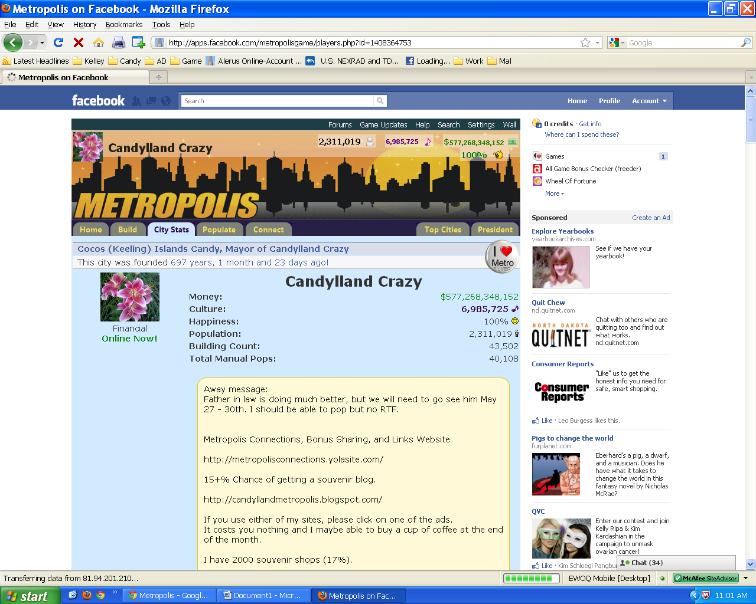

Click Connections Report
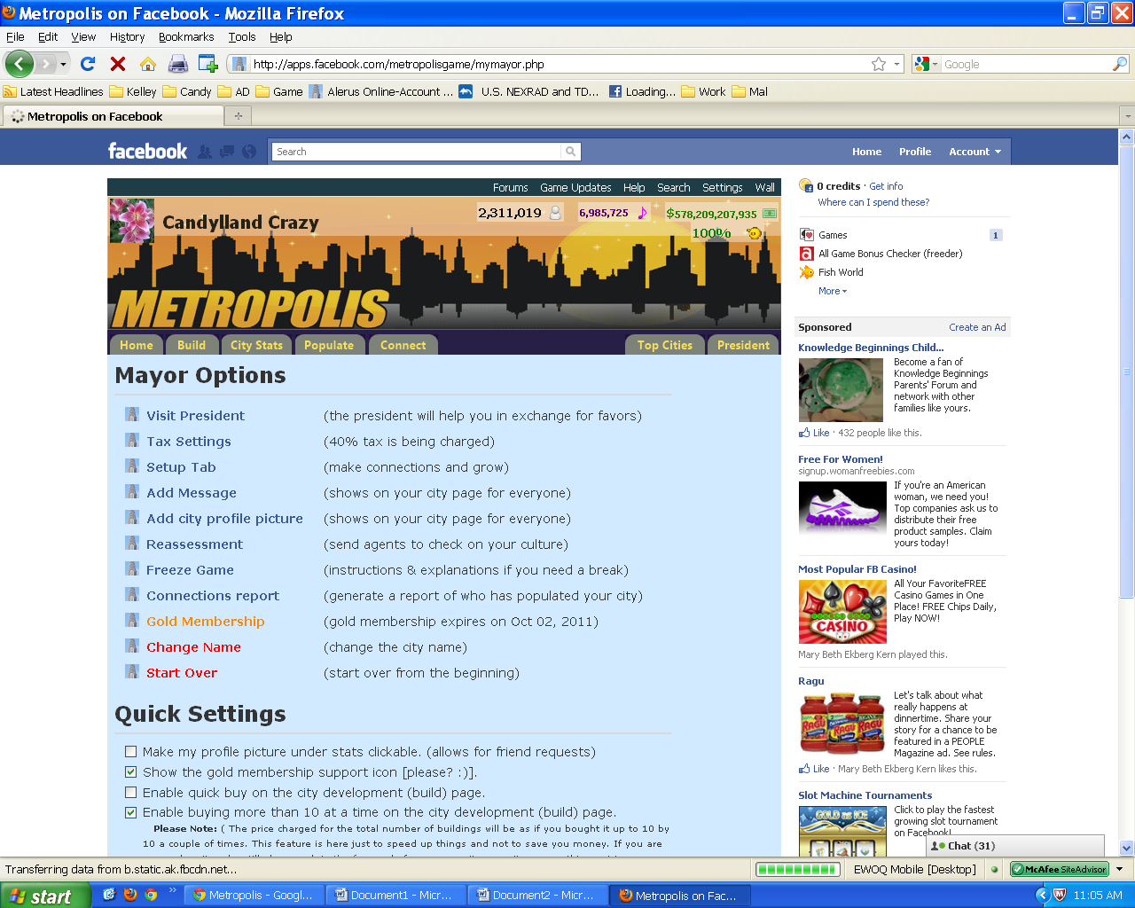
CLICK
HERE
Click ….Times populated the proceding 7 days until they are in a row 7 – 0.
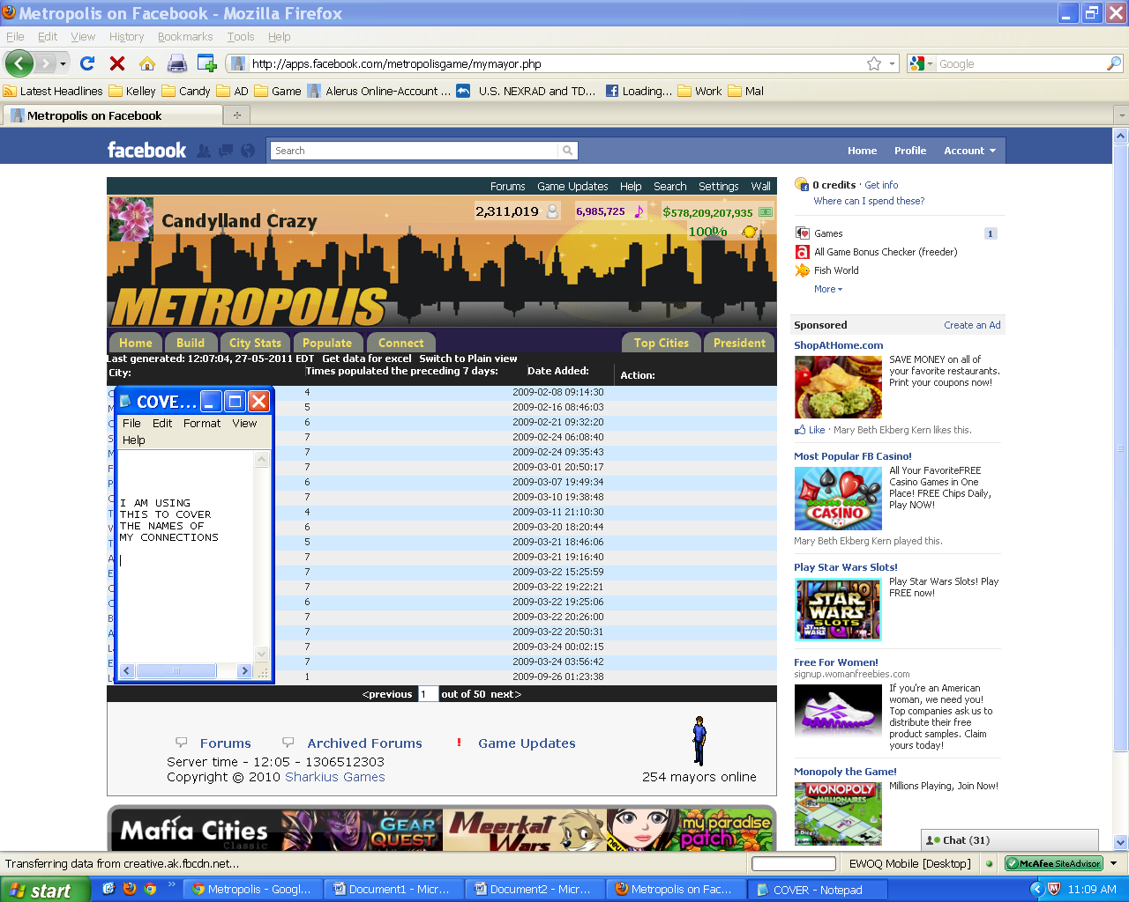
CLICK
HERE
It should look like this:
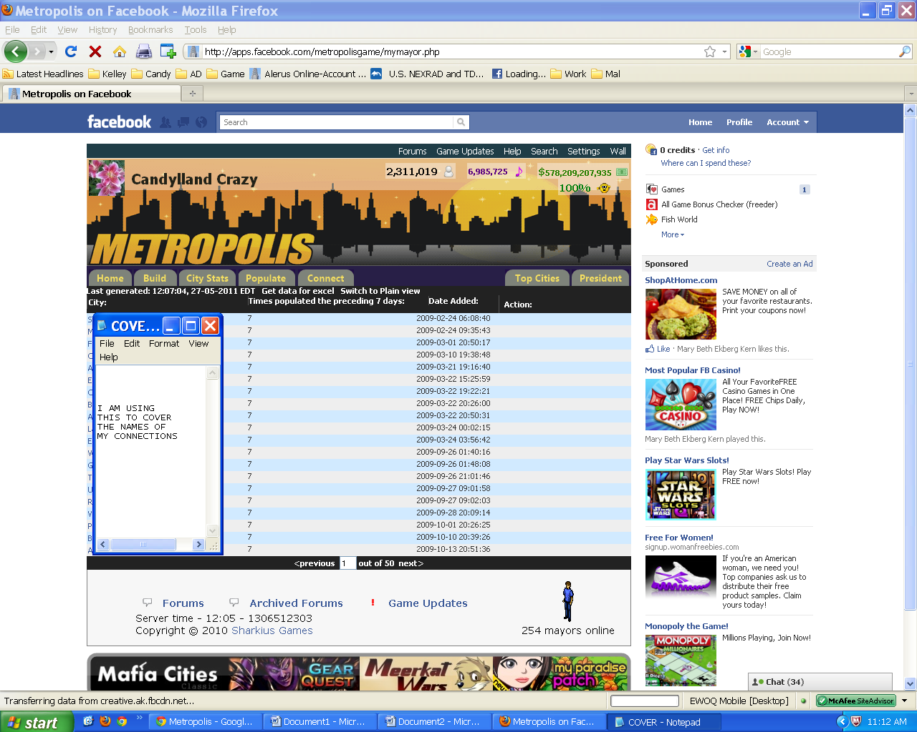
You will be doing the next steps for each page.
Linky won’t work well with this but this will:
Hold the ctrl key down and click on each name. A tab will open up for each one
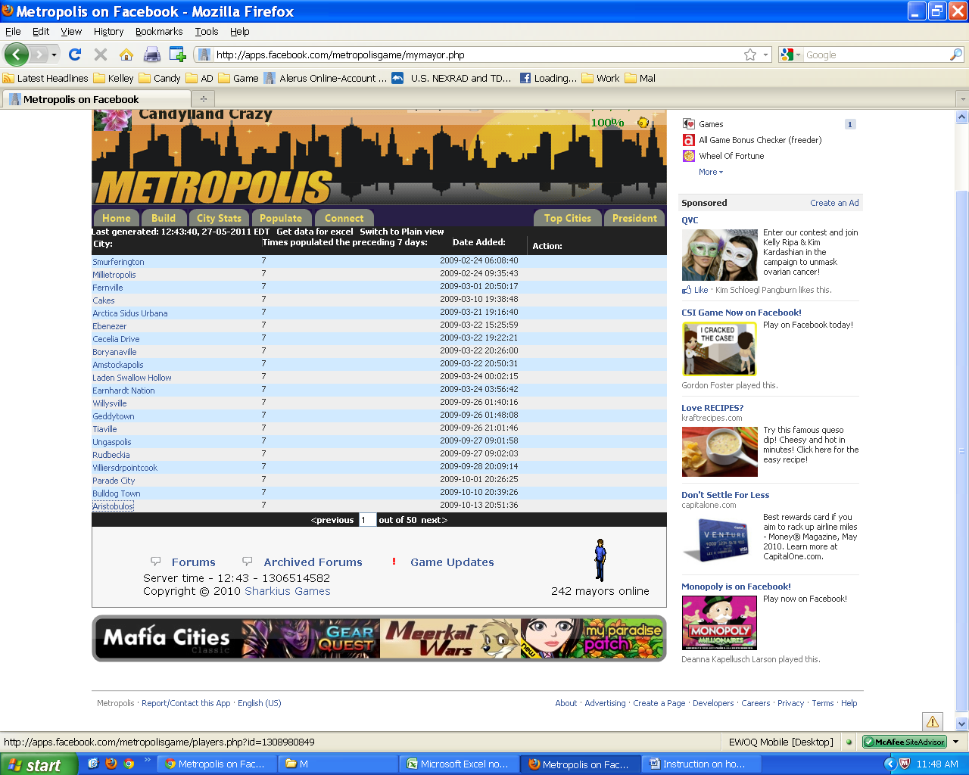
Have a word document open and write what ever message you want:
Example:
I love my 7/7 connections. Thanks for being one of them!
Highlight your message.
Right click …. Copy
Then when you are going through each tab. I:
Ent/pop
Explore
Due to loading/finishing tasks I moved to next tab until I have done both on each tab then I:
Scroll to wall message
Paste message (you may need to copy the message again from time to time but usually not to often.)
Post.
Due again to loading/finishing tasks I moved to next tab until I have done each on each page

I don’t close them until I have done all of them complete and fully loaded.
Quick close of all other tabs
go back to 1st tab that looks like this ~ right click and select close other tabs
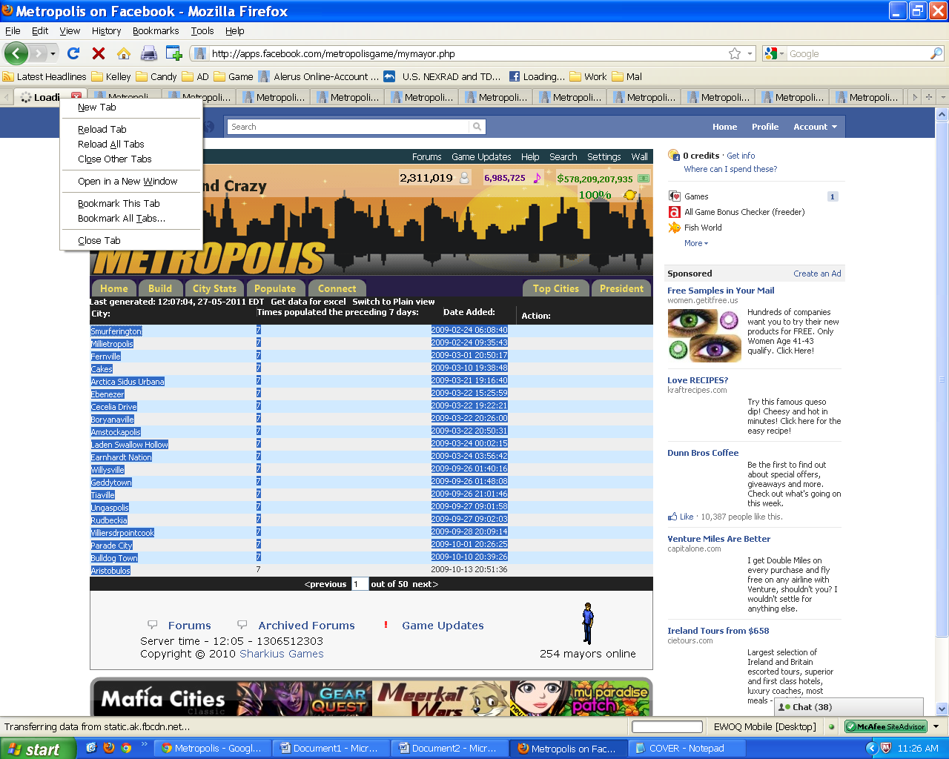
Then move on to the next page.
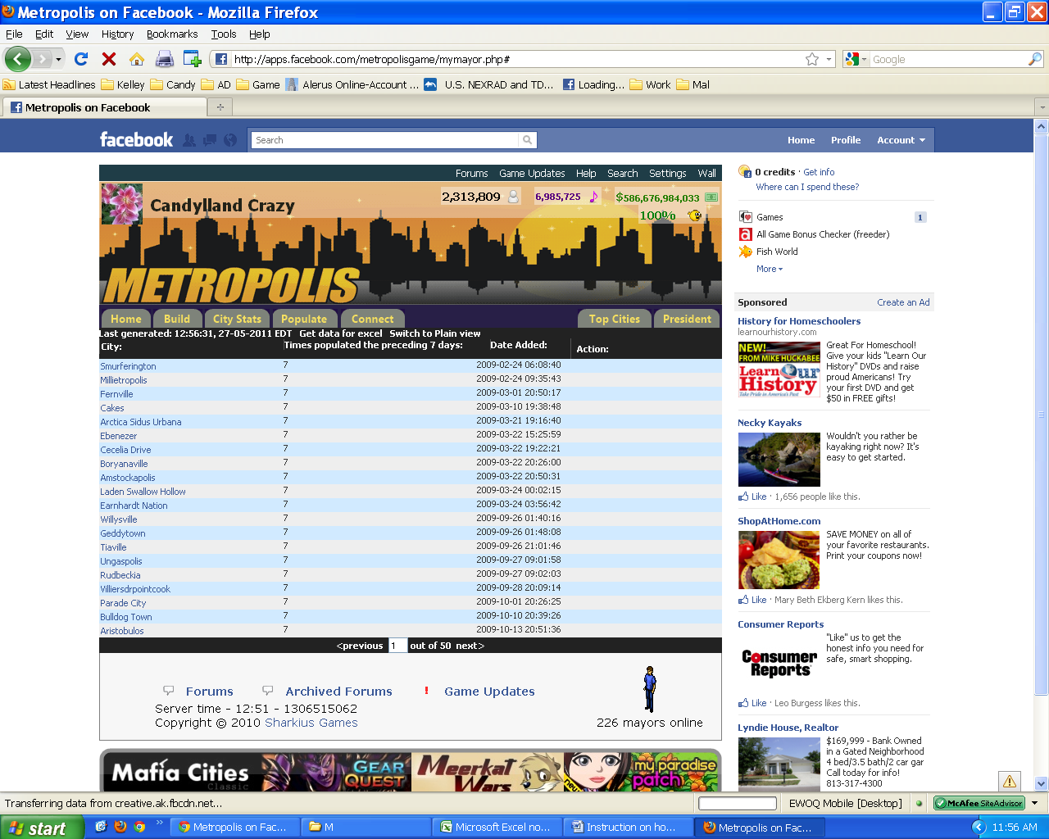
That’s It ~ I hope it helps Linky instruction incase you need them.
When I used Linky on this page it wanted to open 39 Tabs instead of the 15 needed. Here are the linky instructions, but I wouldn’t use it for this:
Highlight all the links you want open like this:
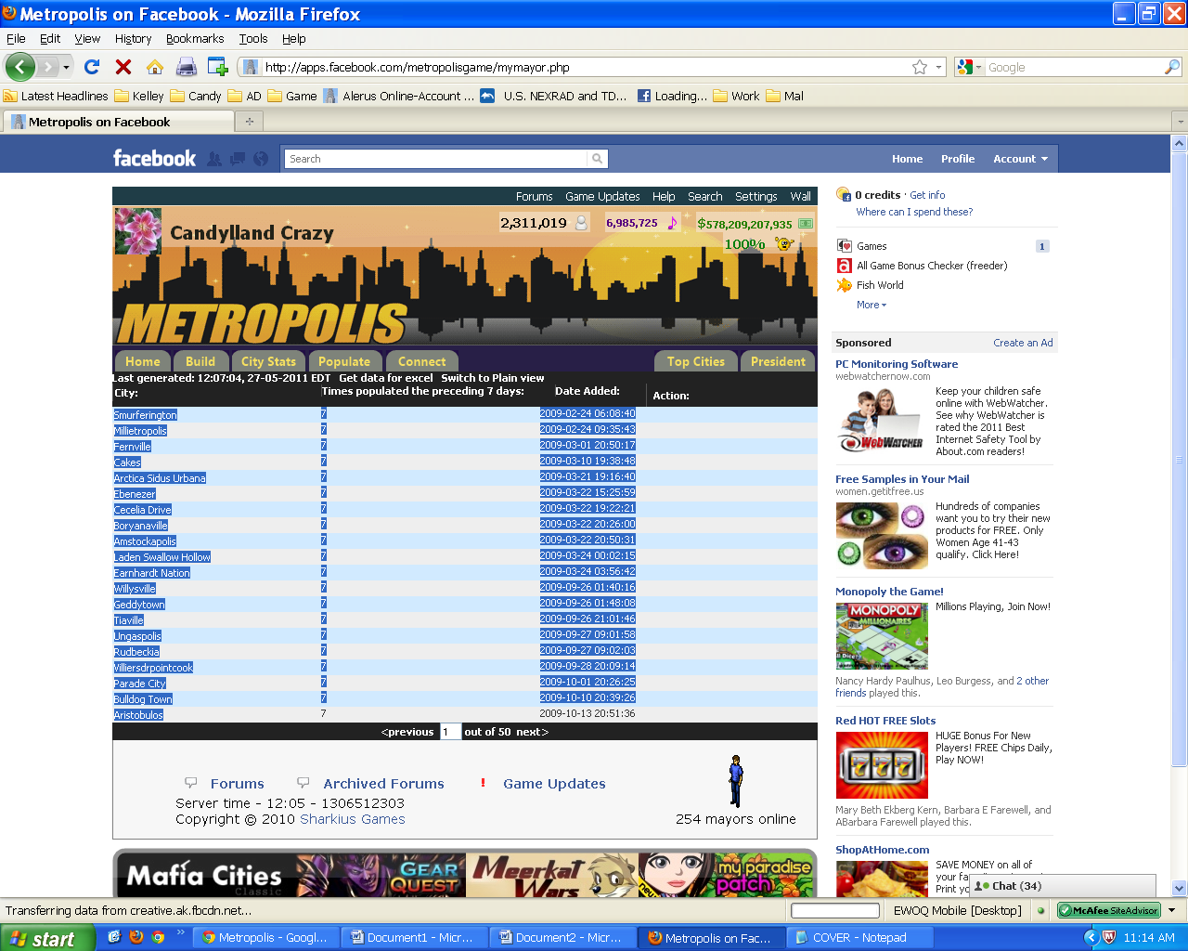
Right click ~ And selected open slected links in tabs
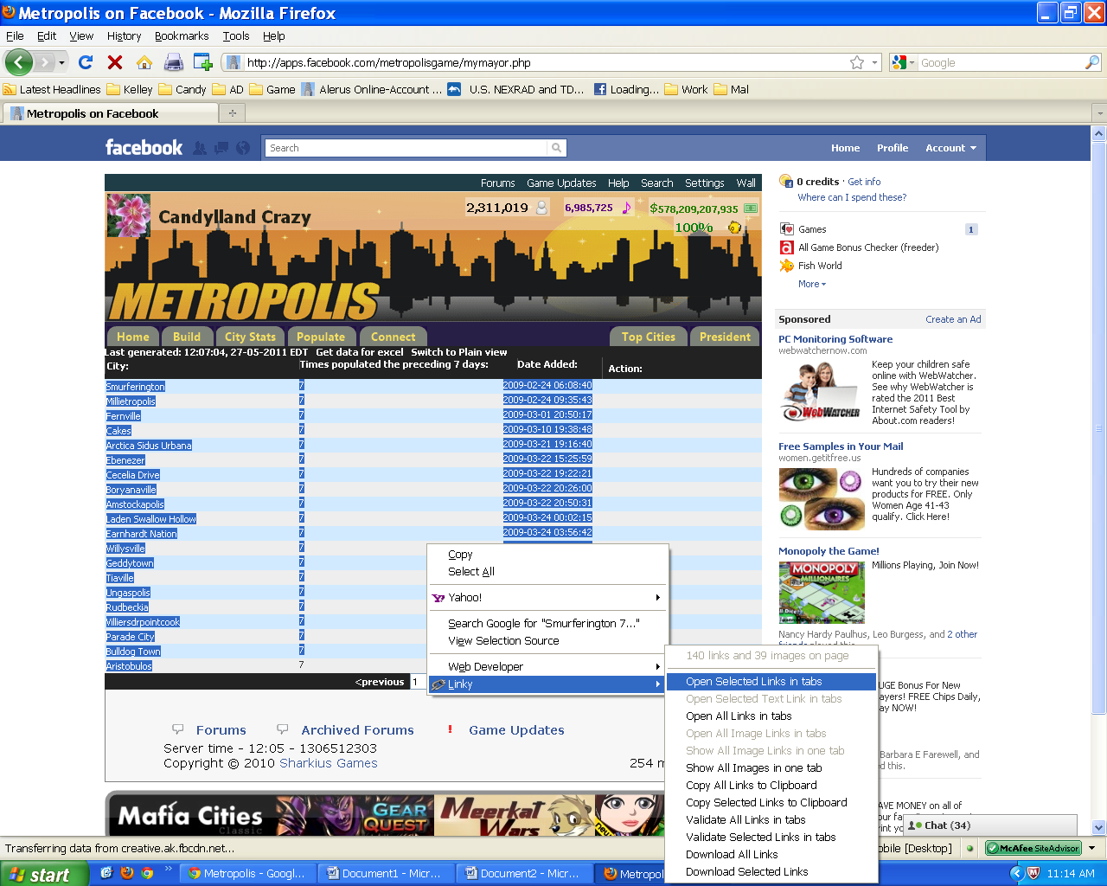

This notice will pop up ~ click on open selected links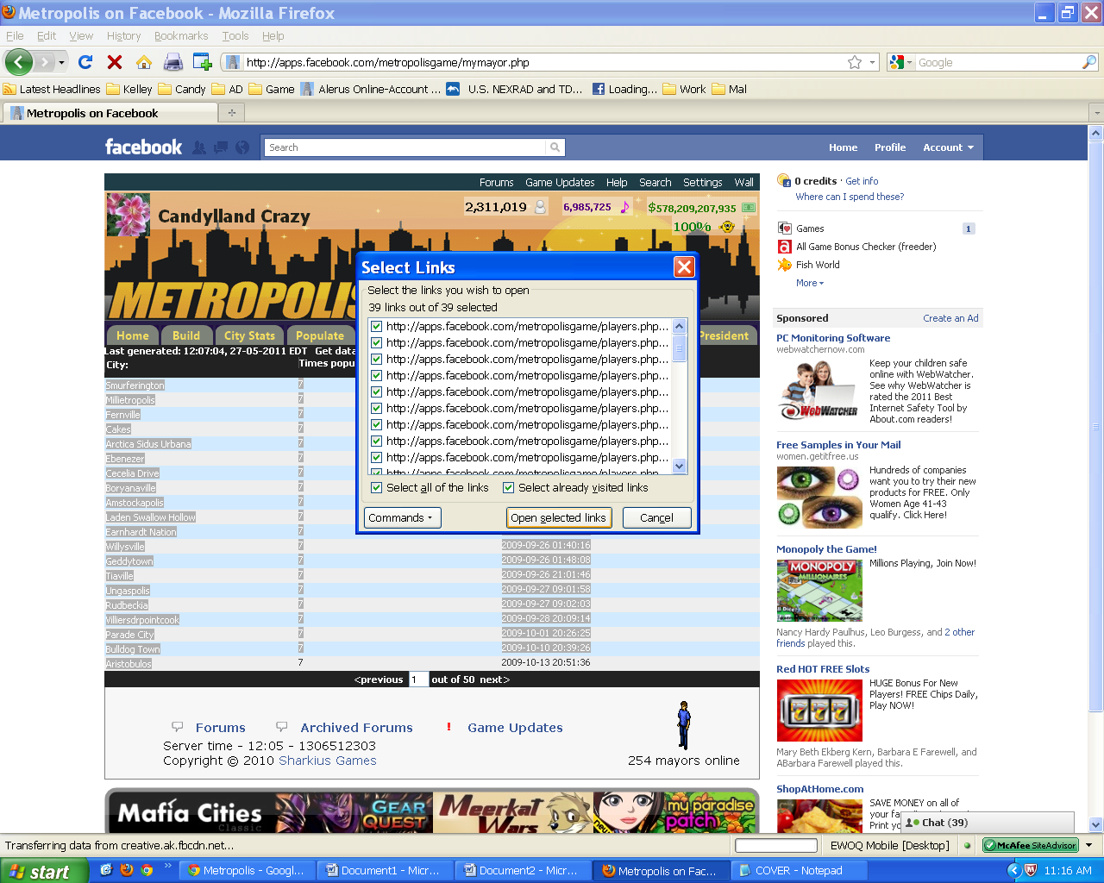

Some other ctrl functions:
Ctrl … page down ----- takes you to the tab to the right
Ctrl … page up ----- takes you to the tab to the left
I use the end (takes you to end of page) and home (takes you to top of page ) button a lot
Anytime you hold the ctrl and click on a link it will open in another tab but keep you on the page your on.

